Proposed Reserve screen solution V1

Functionality description:

1) Initial Reserve Label will be Editable in New claim registration/ Incomplete claim registration.
2) “Reserve Movement” will be editable in “Claim Adjustment” menu.
3) “Outstanding Reserve” will be non editable and will have value based on “c=a+b” formula. (c = outstanding reserve, a = Initial reserve, b = reserve movement)
4) For Claim Adjustment menu “Initial Reserve Label“ will be changed to “Previous Reserve”.
5) Add button will display corresponding record to Edit in reserve.

Screen which will come on click of Reserve button

1) In reserve grid record will be be displayed only for created record of claim type.
For an example if : user has not entered PD claim then PD will not be displayed on this reserve Grid.
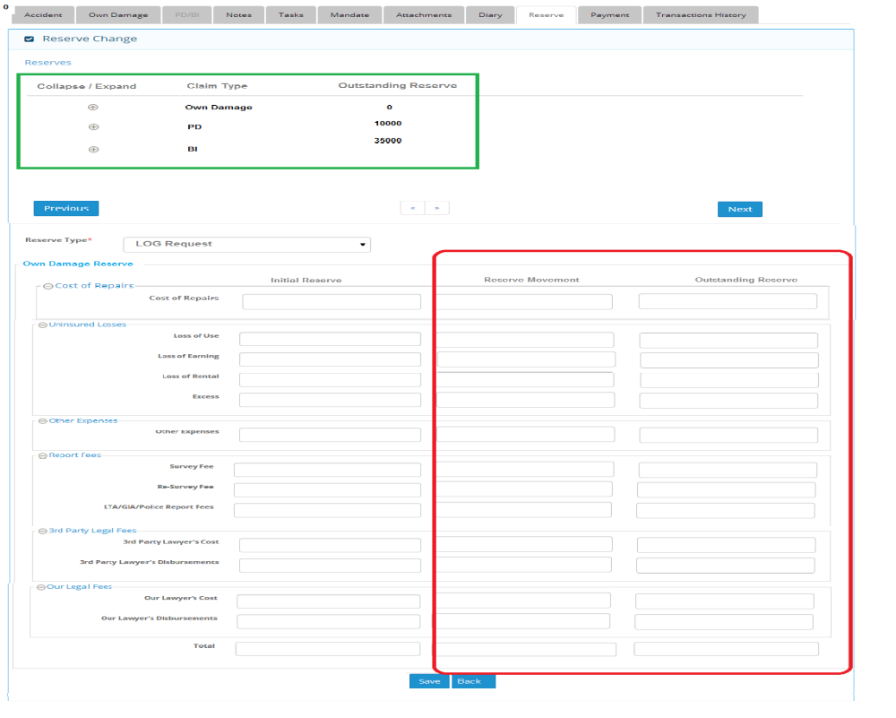

Screen which will come after expanding any entry

